Classification of epithelium
Epithelia are classified into two main groups according to their structures and function including:
1-Covering and lining epithelium
2-Glandular epithelium
The first group is classified into two subgroup groups according to the number of cell layers and the shape of the cells including simple epithelium and stratified epithelium.
1-Simple epithelium
It is composed of a single layer of cells, all of which are in contact with the basal lamina. The shape of the nucleus usually corresponds to the cell form and help to identify the type of epithelium. The simple epithelia are further classified according to the shape of the cells.
a- Simple squamous epithelium
It is composed of a single layer of thin flat cells. From the surface, the cells have mosaic appearance. The nuclei are oval or flat in shape, and usually centrally located produces bulge in the cells. It is so thin layer that offers no protection, where its function filtration and diffusion to allow materials to pass through.
Examples: In parietal layer of Bowman's capsule in the kidney. Lining the walls of blood and lymphatic vessels which called endothelium. Lining serous cavities (pleural, pericardial and peritoneal cavities) which called mesothelium.
b-Simple cuboidal epithelium
It is single layer of cells that are square or box cells. The nuclei are round or spherical and situated centrally in the cell. From the surface the cells appear polygonal in shape. This type offers some protection but it is more prevalent when material must be secreted and absorbed. This type found in many glands as thyroid and pancreas. Lining the kidney tubules.

c- Simple columnar epithelium
It is single layer of cells that are tall and thin. The nuclei are oval or elongated and located near the basal region of the cell. There are two types either ciliated or nonciliated.
1- Simple nonciliated columnar epithelium
It is lined most of digestive tract (stomach, intestine, and gall bladder). In intestine among the columnar cells there are other types of epithelial cells called goblet cells which are mucus-secreting cells and consider gland. The apical surface of epithelial cells contains microvilli to increase the surface area of absorption. These microvilli exhibit striated or brush border appearance at the surface of cells. This type offer protection, lubrication, absorption and secretion.

2- Simple ciliated columnar epithelium
The apical surface of the cells is covered with cilia. It is found in female reproductive system as uterus, uterine tube and oviduct. Also found in small bronchi of lung. The functions are included movement of mucous containing particles in the lung, and partially in movement of eggs in female reproductive system.

d- Pseudostratified columnar epithelium
It is consist of a single layer of epithelial cells. All the cells are rest on the basement membrane. Some of these epithelial cells are tall (columnar cells) and reach to the free surface, whereas other cells (fusiform cells and basal cells) are short and not reach to the free surface. The nuclei of these cells are at different levels (Figure 2). Thus giving the impression that the tissue is composed of more than one layer of cells and appear stratified.
1- Pseudostratified nonciliated columnar epithelium
Duct of salivary gland, epididymis.

2- Pseudostratified ciliated columnar epithelium
The cells at apical surface are ciliated, and are associated with goblet cells. This type found in trachea, bronchi of the lung, and nasal cavity. The functions are protection, secretion, transport of particles out of respiratory tract.
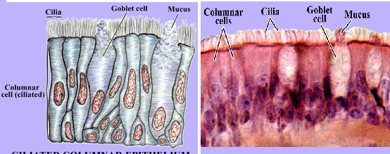
Figure (2): Pseudostratified epithelial tissue and goblet cells in trachea.

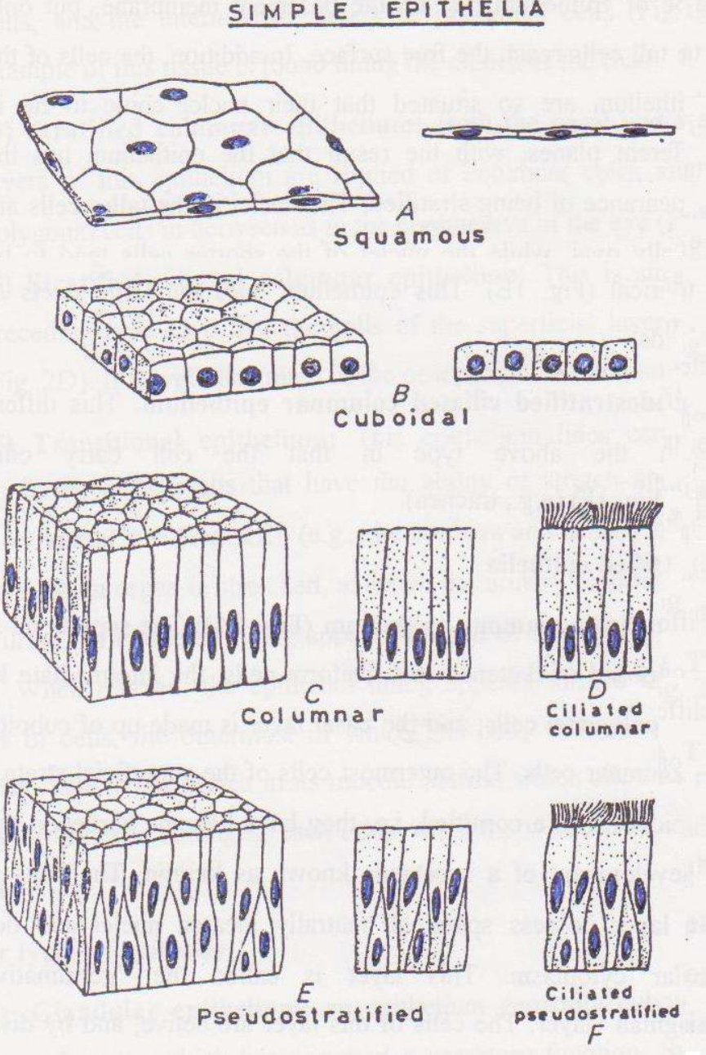

Figure (1): Types of simple epithelial tissues

2-Stratified epithelium
It is composed of two or more layers of cells. Only the cells of the bottom are in touch with the basal lamina. They are very thick and their main function is to protect the tissues that they cover. The shape of the cells closest to the basement membrane is quite different from that of the cells at the top, near the lumen. Mitosis takes place in the basal cells as the cells differentiate, they move upward in the epithelium. The stratified epithelia are further classified according to the shape of the cells at the free surface.
a- Stratified squamous epithelium
It is a thick membrane where its cell is arranged in many layers. The cells of basal layer vary from cuboidal to columnar. The intermediate layers above the basal layer have irregular polyhedral cells. The surface layers have flattened cells and they are usually damaged or rubbed away and replaced by cells in the basal layer which have ability to produce new cells.
There are two types either keratinized or nonkeratinized
1- Stratified squamous keratinized epithelium
This type is composed of multiple layers of cells that are keratinized. This type is found in the epidermis of the skin (Figure 3). The surface is dry where it is composed of dead cells and become keratinized where modified into tough, nonliving layer of material called keratin. This keratin layer at the surface is mechanically strong and confers protection against abrasion, prevents water loss by evaporation and protection against bacterial invasion.

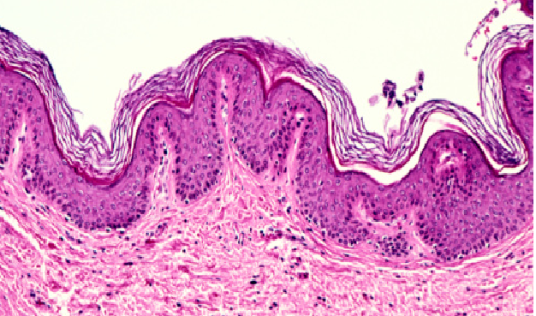
Figure (3) : Stratified keratinized squamous epithelial tissue in skin.
2- Stratified squamous nonkeratinized epithelium
This type is composed of multiple layers of cells .The surface of the epithelium is moist and nonkeratinized (Figure 4).This tissue found in mouth, esophagus and vagina. The functions of this tissue are protection and secretion.
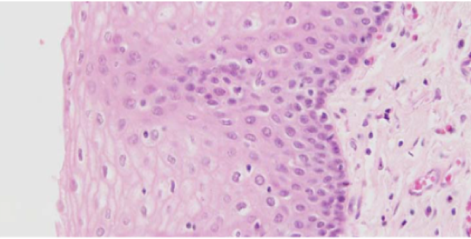
Figure (4): Stratified squamous non keratinized epithelial tissue
in esophagus.
b- Stratified cuboidal epithelium
It is consist of two layers of cuboidal cells. The distribution of this tissue is limited. This tissue is found in ducts of sweat gland, and follicular cells of ovary. The functions of this tissue are protection and secretion.
c- Stratified columnar epithelium
It is consist of many layers of epithelial cells. The basal layers consist of low irregularly cells polyhedral cells (cuboidal cells), and only the surface layer is composed of columnar cells. The distribution is also limited where found in duct of mammary gland and part of male urethra. The functions of this tissue are protection and secretion.
d- Transitional epithelium
The transitional epithelium of the urinary passages is also called urothelium. The urothelium is composed of the following layers:
1-Asingle layer of small basal cells resting on a very thin basement membrane.
2- An intermediate region has from one to several layers of columnar cells.
3-Asuperficial layer is very large polyhedral or bulbous cells called umbrella cells, which are bi or multinucleated and are highly differentiated to protect underlying cells against the cytotoxic effects of hypertonic urine.
This type of epithelium is transitional form between stratified squamous and stratified columnar epithelium according to the degree of distension of bladder (Figure 5).
In contraction state (unstretched condition), it is composed of many layer, the basal layer is cuboidal to columnar in shape. Above this there are several layers of polyhedral cells.
The surface layer consists of large dome-like cells or umbrella in shape and some of which binucleated.
In distention state (stretched condition), the cells are change in shape where the surface layers become long and flattened cells. The number of cell layers decrease and become only few layers. This tissue is located in urinary bladder, ureter, and upper part of urethra. The functions of this tissue are formation of permeability barrier and protection against effect of urine.
Figure (5): Transitional epithelium in ureter.
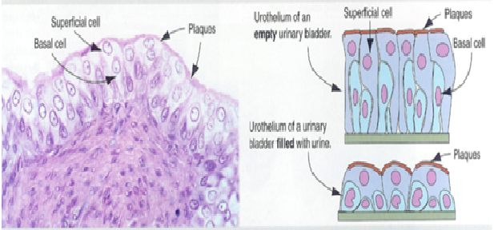

Content:
Classification of epithelial tissue
Simple epithelium
Classification of simple epithelium
Stratified epithelium
Classification of stratified epithelium
Transitional epithelium

Classify simple epithelium
Name the layers of transitional epithelium
Describe psceudostratified epithelium

